Course: SAT ACT Prep
Subject: Mathematical Reasoning
Topic: Arithmetic
Subtopic: Evaluating Remainders
Document: Quick Drill B Resource
Lesson Number: 6
Reference Number: 1006-8

https://youtube.com/c/MrMattTheTutor

- A teacher brings enough cookies to give each of his 30 students three cookies. If seven students decide they don’t want their cookies, how many cookies remain when there are not enough to make sure all students who want cookies get the same number of cookies?
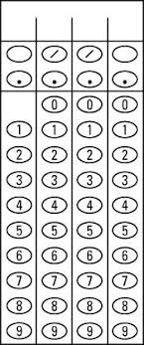

- A teacher brings enough cookies to give each of his 27 students three cookies. If eight students decide they don’t want their cookies, how many cookies remain when there are not enough to make sure all students who want cookies get the same number of cookies?

- A professor brings enough cookies to give each of his 234 students four cookies. If thirty-four students decide they don’t want their cookies, how many cookies remain when there are not enough to make sure all students who want cookies get the same number of cookies?

- Tickets at a raffle are given in the following order: 4 purple, 7 gold, 3 red, 5 green, and then repeats with 4 purple and so on. How many gold tickets will be given out if there are a total of 1000 tickets?

- Tickets at a raffle are given in the following order: 4 purple, 8 gold, 5 red, 9 green, and then repeats with 4 purple and so on. How many gold tickets will be given out if there are a total of 2000 tickets?

- Tickets at a raffle are given in the following order: 7 purple, 5 gold, 3 red, 7 green, and then repeats with 7 purple and so on. How many gold tickets will be given out if there are a total of 2500 tickets?

