Course: SAT ACT Prep
Subject: Mathematical Reasoning
Topic: Arithmetic
Subtopic: Evaluating Remainders
Document: Quick Drill A Resource
Lesson Number: 6
Reference Number: 1006-7

https://youtube.com/c/MrMattTheTutor
- What is the quotient of the remainders of 79 and 123 when divided by 5?
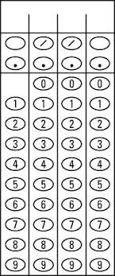
- What is the product of the remainders of 167 and 193 when divided by 7?
- A landscaping job requires 1777.6 pounds of mulch. If each bag of mulch weighs 5.5 pounds, how many bags should be purchased to complete the job?

- A landscaping job has a budget of $1,628.80 for mulching. If each bag of mulch weighs ten pounds and costs $6.40 per bag, how many pounds of mulch are needed another whole bag cannot be purchased?

- Tickets to a private movie screening are handed out in the following order: 3 blue, 5 red, 2 green, 4 yellow, and then repeats starting with 3 blue and so on. What color ticket will the 3000th person be handed?
  - Blue
  - Red
  - Green
  - Yellow

- Beads on a particular necklace are strung in the following order: 2 square beads, 5 round beads, 4 spiral beads, 6 barrel beads, and then repeats with 2 square beads and so on. What shape is the 500th bead to be strung?
  - Square
  - Round
  - Spiral
  - Barrel

