Course: SAT ACT Prep
Subject: Mathematical Reasoning
Topic: Arithmetic
Subtopic: Operations with Radicals
Document: Quick Drill B Resource
Lesson Number: 4
Reference Number: 1004-8

https://youtube.com/c/MrMattTheTutor

- What is the value of the expression$\left(2\left(3\sqrt{2}\right)+3\left(5\sqrt{2}\right)\right)\left(4\sqrt{12}\right)$?
  - $84\sqrt{2}$
  - $168\sqrt{2}$
  - $168\sqrt{3}$
  - $168\sqrt{6}$
- What is the value of the expression$\left(5\left(4\sqrt{3}\right)-3\left(2\sqrt{3}\right)\right)\left(2\sqrt{5}\right)$?
  - $28\sqrt{15}$
  - $38\sqrt{15}$
  - $58\sqrt{15}$
  - $68\sqrt{15}$

- What is the value of the expression$\left(8\left(3\sqrt{5}\right)-2\left(4\sqrt{5}\right)\right)\left(3\sqrt{8}\right)$?
  - $42\sqrt{10}$
  - $56\sqrt{10}$
  - $96\sqrt{10}$
  - $108\sqrt{10}$
- What is the value of the expression ${(-\sqrt{3}{(3\sqrt{2})}^{2})}^{2}$ ?
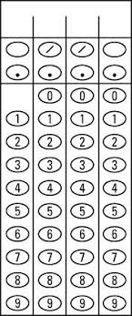
- What is the value of the expression ${(-\sqrt{5}{(2\sqrt{3})}^{2})}^{2}$ ?

- What is the value of the expression ${(-\sqrt{2}{(3\sqrt{5})}^{2})}^{2}$ ?

